# Image Enhancement Matlab Code

// read in image to new variable originalImage

OriginalImage = Imread(‘filePath.fileName.fileExtension’)

Imshow(I)

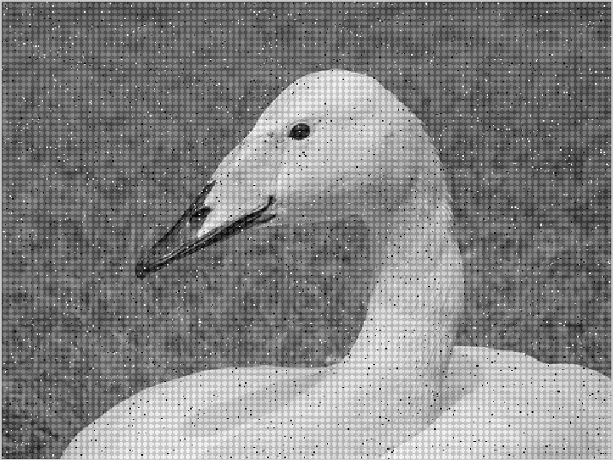

// if image is not already grey convert 3-D array into 2-D array and greyscale else assign

[ rows columns numberOfColorChannels ] = size(I);

If() numberOfColorChannels > 1

ImageGray = rgb2gray(I);

else

ImageGray = I; // image is already gray

End

// Linear filtering

// Input grey scale image

// averaging filter to remove random (salt and pepper) noise

AvergingFilterImage = filter2(fspecial('average',3),ImageGray)/255;

imshow(AvergingFilterImage)

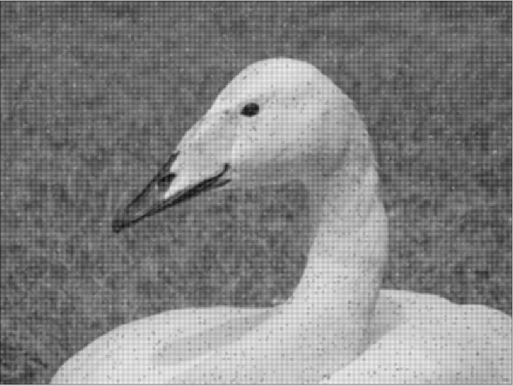

// Median filter removal

MedianFilteredImage = medfilt2(ImageGray,[3 3]);

imshow(MedianFilteredImage)

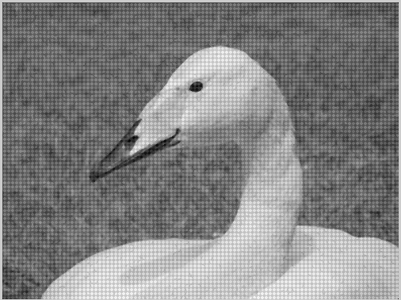

// Adaptive Filtering

// Add Weiner filter

AdaptiveFilteredImage = wiener2(ImageGray,[5 5]);

Imshow(AdaptiveFilteredImage)

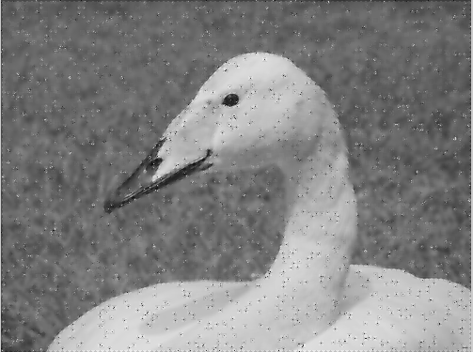

// Structured noise removal will require Fourier Transformation

//Program Code

Task 1 Remove salt and pepper noise: median filter

Task 2 Structured noise removal:

//load Original grey image

OImage = imread('\\ndrive\xw009807\.do_not_delete\desktop.xp\IA assignment\Images\swanNoise.bmp');

References

* <http://uk.mathworks.com/help/images/noise-removal.html>